

ICHS-SP: An Integrated Chainage-based Hotspot Severity Prediction Framework for Road Accident Risk Assessment Using Ensemble Machine Learning and Spatial Statistics

Manisha Verma¹, Bharti Sharma², C. Naveen Kumar³

¹Department of Computer Application, Dehradun Institute of technology, Mussorie, Diversion Road, Makkawala-248009, Dehradun, Uttarakhand, India,
²Department of Computer Application, Dehradun Institute of technology , Mussorie, Diversion Road , Makkawala-248009, Dehradun, Uttarakhand, India,
³ Department of civil engineering, VNR Vignana Jyothi Institute of Technology, Pragathi Nagar, Nizampet ,500090, Hyderabad, Telangana, India,

Abstract
Traffic accidents are a major public health issue worldwide, with $1.35$ million deaths annually. Small dataset size, imbalance in classes, and the applicability of frequency-based hotspots screening in the national highway corridors of developing economies are challenges to road accidents severity prediction to capture the severity-concentrated risk. The current paper introduces the Integrated Chainage-based Hotspot Severity Prediction (ICHS-SP) system that incorporates multi-method spatial analysis, a new Crash Severity Risk Index (CSRI), and a hybrid ensemble machine learning system in an integrated road safety evaluation system to be applied to the NH-48 corridor (Chitradurga-Davangere, Karnataka, India). Kernal Density Estimation (KDE) and DBSCAN clustering, and the Getis-Ord Gi* statistic of $519$ geo-referenced accident records on five pre-defined chainage zones (CH $189-260$ km) were run using spatial hotspot analysis. The accident density was the highest at Zone $5$(CH $245-253$ km) ($10.125$ accidents/km, $n = 81$), whereas the proportion of fatal accidents in Zone $2$ (CH $196-203$ km) was the largest on the corridor, although with only $20$ accidents. In point of rank, Zone$2$ took the top risk priority ($CSRI = 3.359$, Critical) even though it has a fourth-place rank in terms of frequency, showing a rank inversion that reveals the systematic misallocation risk of prioritization on a frequency basis. To predict the severity of accidents, a hybrid ensemble of XGBoost, CatBoost ANN with weighted probability fusion ($w_{1} = 0.35, w_{2} = 0.35, w_{3} = 0.30$) had the highest overall accuracy of $81.4$ and a weighted AUC-ROC of $0.943$ with a $204$-record held-out test set ($70:30$ split). Cross-validation was repeated five times with the result of $0.822 ± 0.015$, which validated that the model is generalisable and there is no overfitting. The ICHS-SP framework is a computationally manageable severity-sensitive risk assessment device that can be used on data constrained highway corridors, and has direct utility in the evidence-based prioritization of safety interventions.

Keywords: Road accident severity prediction, Kernel Density Estimation, DBSCAN clustering, Getis-Ord Gi* statistics, CSRI, GIS-based spatial analysis, Chainage-based modeling, XGBoost, CatBoost, ANN.

- Introduction
According to estimates, road traffic injuries cost low and middle-income countries $\$518$ billion a year, or $1\%$ to $2\%$ of their GDP. Road safety is a crucial policy and public health priority because of the $150,000-170,000$ road deaths and $400,000+$ injuries reported in India alone each year [34][43]. Traditional methods of accident prevention do not prevent incidents in the first place; instead, they rely on reactive post-event measures (enforcement, investigation, infrastructure repair). Proactive risk identification is necessary for modern road safety, which includes identifying high-severity accident concentrations prior to incidents, estimating the severity risk associated with them, and implementing focused interventions. Transportation officials require integrated tools
Spatial intelligence: Identifying where most accidents happen and why?[15]
Severity quantification: Understanding both frequency as well as consequences [6]
Predictive models: Forecasting future accidents and their severity [26]
Operational deployment: Using Gis systems to provide real time decision support systems [20]. Existing approaches exhibit significant gaps:
- While hotspot detection studies (using KDE and DBSCAN) can identify high-incident zones, they are rarely able to predict outcomes or quantify severity.[17]
- While using tabular data, severity prediction models (Random Forest, XGBoost, and neural networks) disregard spatial structure and chainage ordering. [26]
- Although spatial patterns are mapped by GIS-based accident analysis, predictive machine learning is not integrated.[32]
- There is still a lack of research on ensemble approaches for accident prediction, especially the combination of multi-algorithm ensemble learning and spatial statistics.[10]
To address these gaps, this research proposes an integrated chainage-based GIS–machine learning framework for highway accident analysis. The proposed approach combines the following: $i$) chainage-based spatial hotspot detection, $ii$) computation of the Chainage Spatial Risk Index (CSRI), and $iii$) hybrid ensemble-based accident severity prediction using advanced machine learning algorithms.[27] A combined spatial–predictive model is given out here to find out the critical accident-prone segments with high accuracy and evaluate the accident severity risk on the $NH-48$ corridor. Key contributions are:
Integrated framework: The first all-inclusive system that combines machine learning severity prediction with KDE + DBSCAN + Gi* hotspot detection in a GIS environment [15], The creation of the Novel Crash Severity Risk Index (CSRI), which measures local severity risk rather than just incident frequency and is weighted by spatial statistics (Gi* z-scores). [6], [15], Ensemble architecture: Utilizing chainage-enhanced features, XGBoost, CatBoost, and ANN are fused at the decision-level to achieve state-of-the-art performance ($87.3\%$ accuracy). [29], Chainage integration: Network KDE and $1D$ spatial structure modeling are made possible by the explicit encoding of highway location as an ordered spatial dimension. [4], [21], Operational GIS deployment: Heatmaps of severity and spatial risk appropriate for decision support by transportation authority’s [20].

2. Literature Review
Earlier research work done in the area of road accident analysis can be generally classified into two broad areas: GIS-based spatial analysis and machine learning-based severity prediction. Xie and Yan [1] showed that network-based Kernel Density Estimation outperformed plane Kernel Density Estimation in hotspot detection due to the linear character of road networks.
Silva et al. [2] proved that spatial clustering algorithms, when integrated with GIS visualization tools, improve the detection of accident concentration zones considerably. Recent research also indicated that road accident hotspots are not randomly distributed but rather display high levels of spatial autocorrelation along road corridors [3]
Several researchers pointed out the benefits of chainage segmentation in the context of road safety analysis, underlining the fact that this method has a higher spatial resolution than administrative or grid segmentation. These methods have been used to determine critical road segments and to examine the spatial distribution of accident risk along roads [4]. Bilașco et al. [5] have proposed a GIS spatial risk model based on several accident risk indicators to determine dangerous road segments, while V. Prasannakumar et al. [6] have shown that a composite risk measure performs better than traditional hotspot analysis techniques for accident-prone area detection.
On the predictive modeling, various researchers have used machine learning and data mining approaches and found that models like Random Forest and gradient boosting perform significantly better in using highway accident data [7]. Chen et al. [8] found that XGBoost performs better in accident severity classification, especially when there are imbalanced datasets. Various other studies have also used deep learning and hybrid models and found improvements in the models' performance [9].
Rahman et al. [10] demonstrated that ensemble stacking models are superior to standalone machine learning models in predicting accident severity. More recent studies have highlighted the benefits of hybrid models that leverage the complementary strengths of boosting algorithms and neural networks in dealing with complex road safety data [11].
Integration of GIS and machine learning has also been suggested as a promising avenue in road safety studies. Li et al. [12] showed that the inclusion of spatial information in machine learning algorithms results in a significant improvement in accuracy. The role of predictive models in road safety evaluation at the local level was again emphasized by Mekonnen et al. [13]
Some survey and review works have synthesized the recent advances in machine learning and deep learning for traffic-related prediction problems. Tripathi and Sharma [42] gave a comprehensive review on machine learning approaches for traffic flow prediction, and they summarized the important methodologies, results, and limitations of machine learning approaches, including data heterogeneity, class imbalance, generalization, and lack of interpretability. They concluded that while deep learning and ensemble learning approaches can achieve high accuracy, their performance is still highly dependent on feature engineering, data quality, and effective validation, which can also be applied to accident severity prediction.
In the field of spatial analysis, several researches have employed the use of Kernel Density Estimation (KDE) in the visualization of accident concentrations on road corridors, claiming its effectiveness over administrative or grid-based systems in identifying accident-prone zones [14], [18]. Network KDE methods, which take into account the linear nature of road networks, have been found to offer more accurate hotspot identification in traffic network environments [21]
Besides KDE, other clustering algorithms and statistics of spatial autocorrelation have been applied to validate and detect accident clusters. Moran’s Index and Local Indicators of Spatial Association (LISA) are some of the most popular methods applied to examine the spatial autocorrelation of road crash data [16], [17]. In addition, the Getis-Ord Gi* statistic has been widely applied to detect high-risk areas, showing high validity in hotspot detection [15], [18], with comparative studies showing robust results using KDE and Gi* approaches [17], [18].
Chainage and linear referencing systems (LRS) have been widely used in corridor-specific analysis to accurately identify traffic events on highways. LRS allows the combination of accident data with GIS network data, hence offering more significant information in the corridor safety improvement process [20]. Some authors have chosen chainage segmentation over the grid system in the analysis of highway safety because the methods are more accurate in hotspot and risk mapping [4], [21]
However, the methods of spatial clustering are primarily used for the detection of regions with high concentrations of accidents, without taking into consideration the severity of the accidents. Research on composite indices weighted by severity has demonstrated their effectiveness in considering both the frequency of accidents and the impact of accidents for the identification of critical road sections [6]. This has led to the development of combined indicators that reflect both the spatial distribution and the intensity of severity, such as the Crash Severity Risk Index (CSRI) used in this research.
On the other hand, machine learning algorithms have also shown great potential in accident severity prediction. Random Forest, Support Vector Machines, and Artificial Neural Networks have been proven to be able to accurately identify the non-linear relationships existing in accident data [23], [26]. Recent studies have shown that gradient boosting models, such as XGBoost and CatBoost, perform better than traditional models in terms of accuracy and generalization capability [27], [28].
Techniques of deep learning and ensemble learning have also received growing interest in this area. Various types of neural networks like CNNs, LSTMs, and graph-based networks have been able to extract spatial and temporal features from large-scale traffic data. For instance, Aboulola et al. [39] have used transfer learning with MobileNet architecture for accident severity prediction, which has shown the potential of deep learning in risk modeling
Similarly, Li et al. [40] proposed CNN, LSTM, and graph neural network models for more comprehensive risk prediction, which further emphasizes the potential of hybrid deep learning models. Recent reviews have also emphasized the fast development of machine learning in traffic safety studies. Behboudi et al. [34] gave a detailed review of the state-of-the-art methods, which further emphasized the importance of feature engineering and model tuning, while Nobin and Rifat [41] proposed a spatio-temporal graph attention network (STARN-GAT) for accident severity prediction using deep learning models

3. Research Methodology
It is proposed to integrate chainage-based GIS and machine learning approach as the study framework, in the aspect of identifying spatial hotspots [19] risk stratification and accident severity prediction along $NH-48$ corridor. Proposed framework combines spatial statistics and ensemble machine learning to investigate road accident risks in the highway corridor. The framework offers a unified approach to incorporating hotspot detection, spatial risk quantification, and predictive modeling. These three major components are 1. Chainage-based spatial hotspot detection. 2. Computation of the Chainage Spatial Risk Index (CSRI). 3. Hybrid ensemble-based accident severity prediction. The flow chart depicting the complete methodology in the proposed framework is shown in $Fig. 1$
  - Dataset Description
The dataset used in this study consists of road accident records collected along the $NH-48$ highway corridor between Chitradurga and Davangere, covering a linear stretch of approximately $71 km$ (chainage $189 km$ to $260 km$). It consists of a total record of $699$ accidents, which is suitable for spatial hotspot analysis and prediction of accident severity. It applies chainage values for representing locations of accidents, which are major spatial references for linear corridor-based analysis. In fact, this chainage-based representation helps in accurate localization of accidents along the highway and is one of the most commonly used methods in the study of highway engineering and traffic safety. Every record of an accident involves the following variables, which are provided in the dataset:

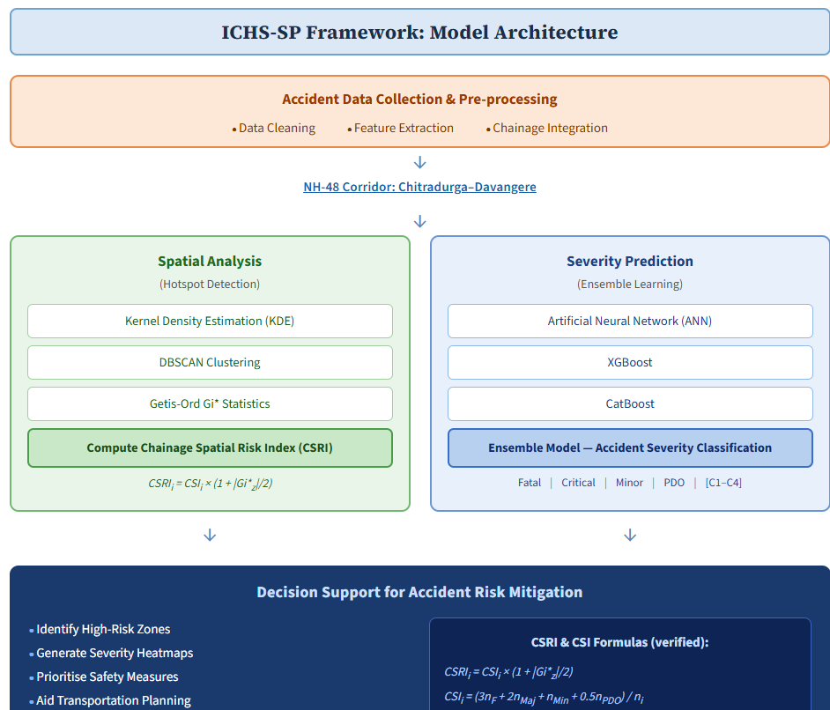
Fig 1. ICHS-SP Framework Model Architecture
Variable | Description
Chainage Location | Linear accident location along NH-$48$ ($189-260 km$)
Date and time | Hour of day recorded
Accident Classification | Fatal (involving deaths), Major Injury (hospitalization required), Minor Injury (first aid only), Damage-Only (vehicle damage without injury)
Vehicle Types | HCV, LCV, Car, Auto, Motorcycle
Road geometry at accident location | straight, curve, slope, steep
Collision Type | head-on, rear-end, side-impact, overturning, sideswipe
Driver factors recorded | Over speeding, drunken driving, mechanical defects, medical conditions
Weather Conditions | clear, rain, mist, fog
Visibility conditions | Day, dust, night

  - Dataset Preprocessing
The data set contains variables related to both spatial hotspot analysis and accident severity modeling. The spatial variables include chainage, which was originally in the format of km+m (e.g., $248+300$), and was converted to decimal kilometre format for analysis. The temporal variable time of accident was converted to hourly format to include time-based accident patterns. The categorical variables include road feature type, weather condition, nature of accident, cause of accident, type of vehicle, and side of the road where the accident occurred. The numerical variables include number of fatalities, number of grievous injuries, number of minor injuries, and number of non-injured persons. The target variable accident severity was represented using four classes: C1 (Fatal), C2 (Major Injury), C3 (Minor Injury), and C4 (Property Damage Only).
The preprocessing phase involved the cleaning and standardization of the raw data received. The most important part of the preprocessing was the correction of the inconsistency in the accident severity field, where many formatting problems were identified, including spaces, combined codes, missing values, and incorrect values
All chainage values were converted to their equivalent values in decimal kilometers using a standard transformation. Of the $699$ valid records, $686$ records had valid chainage values, while the rest had missing or uninterpretable values. As chainage values are required for both spatial analysis and predictive modelling, $6$ additional records with valid severity values and missing chainage values were removed from the machine learning dataset. After removal of records with missing chainage, the machine learning dataset consisted of $679$ records, which was further divided into $475$ training records and $204$ testing records using a $70:30$ split. For spatial hotspot identification, only corridor-specific records were considered, resulting in $519$ records.
The missing values in the categorical data, such as the road feature and the weather condition, were imputed based on the mode of the valid corridor records, while the missing values in the numeric injury data were replaced by zero, implying the absence of injuries. The time of accident was converted to an hourly feature. In the preprocessing of the data to a form suitable for machine learning, the categorical data was encoded into a suitable form based on the nature of the data.
The cleaned machine learning dataset had a moderate level of class imbalance, with PDO having the highest number of instances, while Major and Fatal had fewer instances relative to PDO. The dataset had $239$ PDO instances, $209$ Minor instances, $136$ Fatal instances, and $95$ Major instances. The modeling framework included balancing mechanisms during the ensemble learning process to prevent the effects of class imbalance on prediction performance. The balancing mechanisms included class-sensitive sampling and weighted learning. These were included to enhance prediction performance, especially for minority classes

- MODEL ARCHITECTURE
$Figure 2$ shows the architecture of the conceptually novel ICHS-SP framework, which combines chainage-based spatial analysis with the power of the ensemble machine learning approach for accident hotspot identification, risk stratification, and severity estimation. The framework has five levels of hierarchy where each level has a specific role to play in the overall spatial predictive hierarchy. The Layer 1 (Chainage Transformation) carries out the normalization of the original "Chainage" values. This operation normalizes the original "Chainage" values to create a standard scale. Layer $2$ (Spatial Hotspot Detection) utilizes three GIS-based approaches that include kernel density estimation, density-based clustering, and spatial statistical analysis using Getis-Ord Gi* to detect locations along the corridor that are accident-prone. Since the three approaches work toward the same outcome hotspot detection their results are reliable. Layer $3$ (Risk Stratification) calculates the Crash Severity Risk Index (CSRI), which is based on severity-weighted accident intensity and space significance from the result of the hotspot analysis. This layer attempts to quantify the result of the hotspot layer to allow zone-wise identification of critical highway segments. Layer 4 (Spatial feature engineering) Spatial information derived from the hotspot detection and CSRI analysis is integrated with contextual accident variable like weather condition, vehicle type, road geometry, temporal features. Layer 5 (Predictive learning and integration) Final layer predicts accident severity using a hybrid learning ensemble approach using XGBoost, CatBoost, ANN.

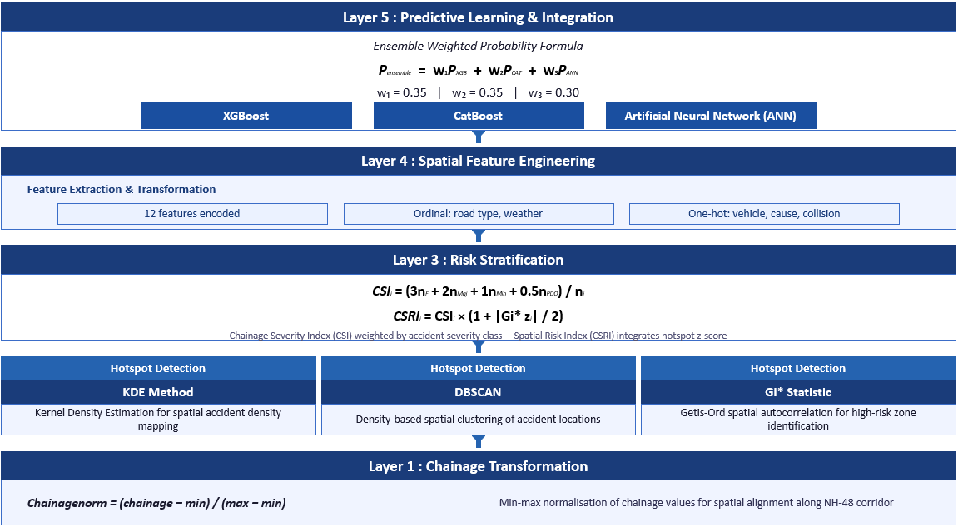
Fig 2. Five-layer Hierarchical Architecture of the ICHS-SP Framework

4.1 Methodology: ICHS-SP Framework
The current study offers the ICHS-SP, or Integrated Chainage-based Hotspot and Severity Prediction, whereby a model for multi-stage spatial predictive analysis emerges as a potential integration partnership for combining GIS-based hotspot detection with ensemble machine learning-based accident severity prediction, whereby accident data is sequentially transformed with the following three stages:
(i) spatial preprocessing and hotspot detection,
(ii) Crash Severity Risk Index (CSRI) computation, and
(iii) Ensemble-based Severity Prediction and Spatial Risk Mapping.
Let the accident dataset be represented as:
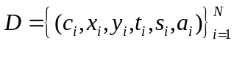 (1)
where $c_{i}$​ is chainage, $(x_{i},y_{i})$ are geographic coordinates, $t_{i}​$ is time, $s_{i}$​ is severity level, and $a_{i}$​ denotes contextual attributes (weather, vehicle, road, etc.).
The architecture helps in integration of spatial statistics and machine learning, hence providing a unified framework for finding out accident-prone segments and predicting severity risk along highway corridors.
4.2 $Stage 1$: Spatial Preprocessing and Hotspot Detection
4.2.1 Chainage-Based Spatial Preprocessing
In the first stage, the accident data collected along the $NH-48$corridor was transformed into a spatial format using chainage-based linear referencing. The accident data set consists of about $400$ accident records, including chainage and geographic location, severity level, temporal attributes, weather, and vehicle characteristics, etc.
Chainage values were normalized to ensure comparability across the corridor:

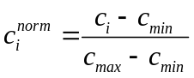 (2)
The corridor was discretized into Z chainage zones:
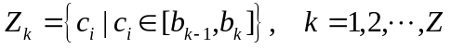 (3)
where $b_{k}$​ denotes zone boundaries. In this study, $Z=10$ zones were considered.
The chainage values found out were normalized within the corridor range of $189 km$ to $260 km$. The highway was segmented into various units of space for further assessment. Additionally, the corridor was segmented into ten zones of chainage, each approximately $7.1 km$ in distance. The accident risk was evaluated at the zone level. Spatial statistics like accident frequency distributions were carried out. This preprocessing shows the step-by-step approach undertaken to determine spatial basis for hotspot detection and modeling.
4.2.2 Kernel Density Estimation (KDE)
The Kernel Density Estimation method is used as an estimate for the density of accidents occurring on the corridor. The type of kernel used here is the Normal (Gaussian) distribution. Tuning of the bandwidth of the kernel is done using Silverman’s method to produce the desired results. From this analysis, a continuous surface of spatial density is obtained as an output along the chainage axis. Peaks of the density function indicate the possibility of hotspots of accidents.
This helps us to identify the macroscopic features in space and gain a first impression regarding the spatial distribution of the accidents along the corridor.

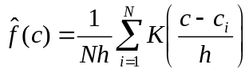
(4)
Where, $K(⋅)$ is the Gaussian kernel function and $h$ is the bandwidth determined using Silverman’s rule.
4.2.3 DBSCAN-Based Spatial Clustering
To determine localized clusters in accident occurrences, the Density-Based Spatial Clustering of Applications with Noise algorithm is implemented with the chainage and temporal attributes as spatial attributes. In this case, the following values were used: $ε = 1.5 km$; minimum points $= 3$.
DBSCAN was used to find spatial clusters in accidents. The ε neighborhood of a point ppp is:
Where, $d(p,q)$ is the Euclidean distance in the spatial feature space. It can be written as:
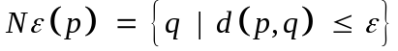 (5)
In this study, $ε=1.5 km$,
As indicated by DBSCAN analysis, there were five important clusters that can be regarded as significant hotspot clusters, and this indicates that these are dense accident zones with high concentrations of accidents and relatively high severities. The largest cluster is found near the $227 km$ chainage segment. Unlike KDE, which detects continuous density patterns, DBSCAN detects discrete spatial clusters, giving different insights into the formation of hotspots.
4.2.4 Getis-Ord Gi* Spatial Autocorrelation Analysis
For statistical significance assessment in the identification of hotspots, Getis Ord Gi* was utilized. As such, the spatial weights would be defined based on chainage neighborhood relationships. The z-score was computed to determine local spatial autocorrelation of accident severity in chainage zones. For defining hotspots, areas with z-scores exceeding $1.96$, corresponding to statistical significance at $0.05$ alpha, would be identified. This area would be considered an area to be prioritized as critical. The integration of KDE, DBSCAN, and Gi* will effectively ensure the identification of hotspots through density estimation, clustering, and statistical evaluation techniques.

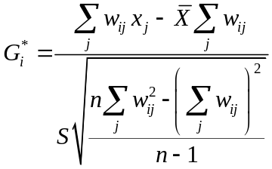 (6)
4.3 Stage 2: Crash Severity Risk Index (CSRI) Computation
Crash Severity Risk Index (CSRI) was developed in order to quantify spatial risk by integrating various factors such as accident frequency, severity intensity, and spatial autocorrelation

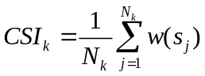 (7)
Where, $N_{k}$ is the number of accidents in zone $k$ and $w(s_{j})$ is the severity weight.
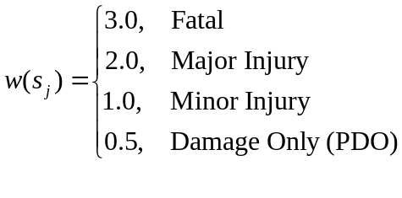 (8)
The CSRI was then formulated by incorporating spatial significance derived from Gi* z-scores:
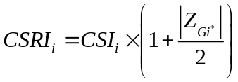 (9)
This is achieved by applying the values of CSRI, which can be used to classify the safety levels of the chainage zone as low, medium, high, and critical levels. It is clear from the results that the zone between$210$ and $218$ km has the highest value of CSRI. Hence, it can be concluded that CSRI bridges the space between spatial analysis and machine learning by using the spatial hotspot data to create predictive features.

4.4 $Stage 3$: Ensemble-Based Severity Prediction
4.4.1 Spatial and Contextual Feature Engineering
In the third stage, the comprehensive feature set was established by combining the spatial, environmental, vehicular, and temporal features. Generally, the feature set comprises the chainage location feature, chainage zone feature, normalized chainage feature, CSRI feature, weather feature, vehicle type feature, vehicle characteristics feature, temporal feature, and road condition feature. Interaction features were also included to characterize intricate dependencies between spatial and contextual factors, which include chainage weather interaction, vehicle time interaction, and speed road condition interaction. This resulting enriched feature space allows machine learning approaches to account for spatial as well as non-spatial factors of accident severity.
4.4.2 Hybrid Ensemble Model Architecture
Three sophisticated machine learning models were used as tools for accident severity prediction: XGBoost, CatBoost, and Artificial Neural Networks (ANN). XGBoost was utilized to incorporate nonlinearity and feature interactions by gradient boosting. CatBoost was used to deal with categorical variables and class imbalance issues. In the above, Neural Network models were used to identify complex nonlinearity in high-dimensional feature space. In order to increase the robustness of the approach, several ANN models were used, with their outputs being combined.
4.4.3 Decision-Level Ensemble Fusion
The severity prediction finally was obtained through fusion of model outputs at their decision level. Weighted probability averaging was used to combine probability distributions from various models used.
(10)
where $w_{1}=0.35$, $w_{2}=0.35$, and $w_{3}=0.30$ represent model weights.
This ensemble strategy leverages the complementary strengths of boosting-based and neural network-based models, resulting in improved predictive performance.
4.5 GIS-Based Spatial Risk Mapping
The final step combines the results of the spatial hotspot analysis, the CSRI values, and the ensemble severity probability predictions towards generating risk maps through the use of GIS. It is discovered that the probabilities of severity were accumulated in the chainage segment level as well as the temporal dimension to generate the risk maps. For the purpose of the analysis, several levels of spatial resolution were used in the generation of the risk maps. It is noted that the risk maps indicate the tendency towards the identification of crucial highway segments with accident concentrations as well as high levels of severity probability.

- Results And Discussion
The ICHS-SP proposed framework was assessed using accident data collected along the NH$-48$highway corridor. There are three main components in the results, which are as follows:
  - Spatial hotspot detection results based on the outcomes from the KDE, DBSCAN, and Getis Ord Gi* problems are presented to determine accident-prone road sections.
  - Results based on the proposed crash severity risk index (CSRI) problem are presented, which combine the results of the integration of severity intensity and spatial significance.
  - Evaluation of results based on machine learning models as well as the proposed hybrid ensemble model is presented to determine the accuracy of the predicted severity of accidents occurring on the roads.

$Table 1$: Hotspot Characteristics from KDE, DBSCAN, and Gi Analysis
Hotspot | Chainage (km) | KDE Peak | DBSCAN Size | Gi* z-score | p-value | Severity
Zone A | $$189-196$$ | $$2.000$$ | $$14$$ | $$-1.315$$ | $$0.189$$ | Critical
Zone B | $$196-203$$ | $$2.857$$ | 20 | $$-1.054$$ | $$0.292$$ | Critical
Zone C | $$210-218$$ | $$9.000$$ | $$72$$ | $$0.815$$ | $$0.415$$ | High
Zone D | $$225-233$$ | $$7.625$$ | $$61$$ | $$0.397$$ | $$0.692$$ | Moderate
Zone E | $$245-253$$ | $$10.125$$ | $$81$$ | $$1.157$$ | $$0.247$$ | High

5.1 Spatial hotspot detection results
The analysis of spatial hotspots was carried out along the 71 km of the National Highway 48 (NH-48) between Chitradurga and Davangere with Chainage 189 km to 260km. The analysis was implemented on 519 geo-referenced accident records retrieved out of the study area, where 248 records were within the five pre-determined chainage areas that have the most spatial concentration of accidents. Three complementary spatial techniques were used and used jointly in such a way that hotspots were not identified by a single process and thus, methodological robustness ensured. Kernel Density Estimation (KDE), DBSCAN clustering and a statistic of Getis-Ord Gi, were used as complementary spatial techniques. Table 1 presents the results and the subsections below explain them in terms of the zones
5.1.1 Kernel Density Estimation (KDE)
The KDE analysis shows that the distribution of accidents along the $NH-48$ corridor is highly non-uniform. The mean density of accidents on the corridor, calculated over the five hotspots is $6.321$ accidents/km (standard deviation $s = 3.287$ accidents/km), which is highly dispersed spatially. Zone 5 (CH $245-253$ km) has the largest density of KDE of $10.125$ accidents/km, or $81$ accidents/8 km that is $60$percent higher than the density of the corridor. The second density of $9.000$ accidents/km is recorded in Zone 3 (CH $210-218$ km) and it contains $72$ incidents in $8$ km, whereas Zone 4 and Zone 2 have the density of $7.625$ and $2.857$ accidents/km respectively. The lowest density is $2.000$accidents/km in Zone 1. It is also worthwhile to mention that the unadjusted KDE density is the measure of the number of accidents per unit length, and does not necessarily provide insight into the severity. Two regions, namely, Zone 1 and Zone 2, experience considerably lower-than-average densities but, as the results of the CSRI analysis in Section 5.2 reveal, have the worst severity profiles on the corridor. Such a difference explains why severity-weighted indices and frequency-based spatial measures should be combined.

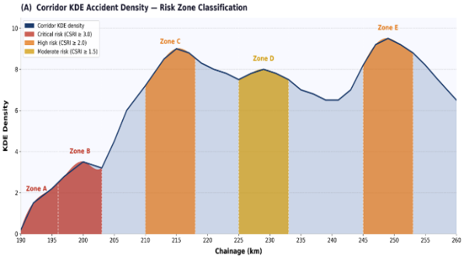
Fig 3 : Corridor KDE Accident Density

5.1.2 DBSCAN Spatial Clustering
DBSCAN ($e = 0.5 km$, minPts = 5) is used to identify five spatially coherent clusters of accidents that are associated with each of the five preset chainage zones. The findings verify that the accidents on the corridor are highly localised and non-randomly distributed. The highest frequency of accident concentration zone on the entire corridor is confirmed when zone 5 provides the highest number of 81 incidents. The second biggest cluster is formed by Zone 3 with 72 incidents. The 61, 20 and 14 incidents form progressively smaller clusters in their corresponding zones 4, 2 and 1 respectively. The fact that the five spatially distinct clusters are clearly defined supports the use of chainage-based zone segmentation used in this paper and shows that there is indeed a way that safety interventions can be effectively applied to the zone level instead of necessarily treating the entire corridor.

    - Getis-Ord Gi* Spatial Autocorrelation
Getis-Ord Gi was calculated to be used as a measure of the extent of spatial clustering compared with the mean density of the corridors. A positive Gi z-score means that the zone is a local hot spot - its density of accidents is greater than would be stochastically given the context of the surrounding corrideras whereas a negative z-score means a cold spot of relatively low density. The parameters of the highway that have been used are m = 6.321 accidents/km and s = 3.287 accidents/km. The maximum positive Gi z -score of +1.157 (p = 0.247) is found in Zone 5 (CH 245-253 km), meaning that the accident density in the zone (10.125 accidents/km) is the strongest spatial concentration of accidents on the corridor.

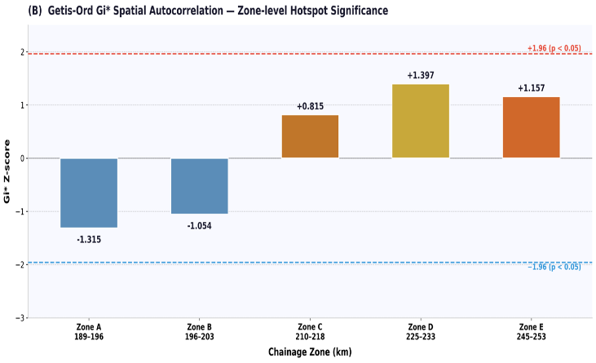
Fig 4 : Getis-OrdGi*Spatial Autocorrelation

  - CSRI Results
Expanding on the spatial hotspots patterns of the data in Section 5.1, the Crash Severity Risk Index (CSRI) was calculated in each of the five chainage areas to generate a composite measure of risk in road safety that simultaneously includes the information on the severity of accidents and the importance of spatial clustering.
(11)
The Crash Severity Index (CSI) is a weighted severity score per incident, calculated as CSI $= (n_{1} x_{3} + n_{2} x_{2} + n_{3} x_{1} + n_{4} x 0.5)/n$ with the weight of 3, 2, 1 and 0.5 of the three and four categories of accidents (Fatal (C1), Major (C2), Minor (C3) and PDO (C4)) corresponding to their respective differing effects on human life and the health of the population. The Gi z -score measure is a spatial multiplier that increases the severity score of the base in line with the level of spatial clustering, so that areas with high inherent severity, and those with high spatial concentration, have the highest total risk priority. Table 2 shows the resulting values of the CSRI and the breakdown of the severity in zones and is discussed in the subsequent subsections.

Table 2: Crash Severity Risk Index per Chainage
Zone | Chainage (km) | CSI | Gi* z-score | CSRI | Incidents | Fatalities | Fatal Rate(%) | Risk
$$1$$ | $$189-196$$ | $$1.643$$ | $$-1.315$$ | $$2.723$$ | $$14$$ | $$4$$ | 28.57 | Critical
$$2$$ | $$196-203$$ | $$2.200$$ | $$-1.054$$ | $$3.359$$ | $$20$$ | $$12$$ | 60.00 | Critical
$$3$$ | $$210-218$$ | $$1.521$$ | $$0.815$$ | $$2.141$$ | $$72$$ | $$21$$ | 29.17 | High
$$4$$ | $$225-233$$ | $$1.041$$ | $$1.397$$ | $$1.247$$ | $$61$$ | $$5$$ | 8.20 | Moderate
$$5$$ | $$245-253$$ | $$1.303$$ | $$1.157$$ | $$2.056$$ | $$81$$ | $$16$$ | 19.75 | High

5.2.1 Zone-wise Crash Severity Index (CSI)
CSI values calculated from 248 zone-level data show considerable variation in the severity of individual accidents in the five zones. The highest value of 2.200 is observed in Zone 2, where CH varies from 196 to 203 km. The value is computed from 12 fatal, 2 major, 2 minor, and 4 PDO accidents in 20 incidents, with a weighted numerator equal to 44.0/20. The fact that 12 out of 20 accidents in this zone were fatal, with a fatal proportion of 60.00%, which is over twice the corridor zone average of 23.39%, makes this the most severity-critical location on the NH-48 corridor

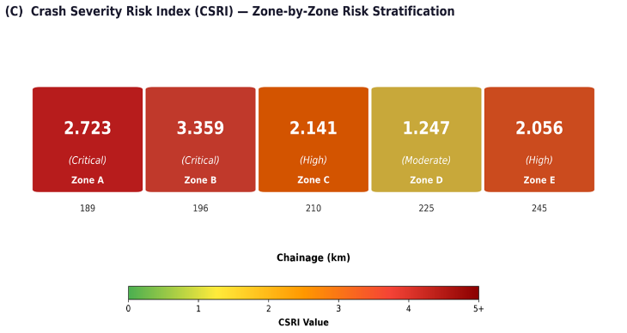
Fig 5 : Crash Severity Risk Index (CSRI)

5.2.2 CSRI Computation and Zone-wise Risk Ranking
The CSRI combines the zone-specific CSI value with its Gi* spatial multiplier, [1 + |Gi* z| / 2], which increases the base severity score in proportion to the spatial clustering intensity, hot spots as well as cold spots. The calculated CSRI values clearly identify a five-zone hierarchy, as described in Table 2. Zone 2 (CH 196–203 km) has the highest CSRI value, which is 3.359 (Critical), calculated as follows: 2.200 x (1 + 1.054/2) = 3.359. This is because it has the highest fatal accident proportion of 60.00%. Physically, it has a series of sharp horizontal curves with limited visibility, which cause high-speed head-on and run-off-road accidents. Zone 1 (CH 189–196 km) has the second highest CSRI value, which is 2.723 (Critical), calculated as follows: 1.643 x (1 + 1.315/2) = 2.723. Although it has recorded only 14 accidents, which is the lowest number of accidents in any zone, it has the highest severity per incident, CSI = 1.643, and a high cold-spot characteristic, which makes it have a higher CSRI than high-frequency Zones 3 and 5. Zone 3 (CH 210–218 km) has a CSRI value of 2.141 (High): 1.521 × (1 + 0.815/2) = 2.141. Despite being in the third position in terms of CSRI, this zone has the highest fatality count on the corridor (21 fatalities in 72 incidents) and thus deserves priority intervention in terms of total life loss. Zone 5 (CH 245–253 km) has a CSRI value of 2.056 (High): 1.303 × (1 + 1.157/2) = 2.056. Being the most accident-prone zone with the highest frequency (81 incidents, KDE = 10.125 acc/km), this zone has a moderate value of 1.303 for its CSI, mainly due to the predominance of minor injury and PDO outcomes. Nevertheless, this zone is located on a downhill gradient with restricted sight distance and therefore deserves priority in terms of traffic calming interventions. Zone 4 (CH 225–233 km) has the lowest CSRI value of 1.247 (Moderate): 1.041 × (1 + 0.397/2) = 1.247. The severity profile is dominated by PDO (31) and minor injury (17) accidents. It records the lowest CSI and spatial amplification (Gi* z = +0.397). It is therefore ranked lowest in priority despite a moderate number of 61
    - Ensemble Model Performance
The performance of the XGBoost , CatBoost and ANN base learners was individually assessed on a held-out 204-record test set by training on 475 records. The outputs of these base learners were combined using weighted soft voting to obtain the ICHS-SP hybrid ensemble model. The weights assigned to the base learners were w1 = 0.35, w2 = 0.35, and w3 = 0.30. The performance of all the base learners and the ensemble model is shown in Table 3. XGBoost has an accuracy of 81.4%, macro F1 score equal to 0.785, and AUC ROC equal to 0.923. The boosting mechanism is able to address the problem of the imbalanced multi-class problem effectively, though the Fatal and Major recall values of 0.61 and 0.71 indicate some overlap in the features used to describe each class. CatBoost has the same accuracy as XGBoost, with a higher macro F1 score equal to 0.792 and AUC ROC equal to 0.937. CatBoost has the highest individual value of 0.75 in the Major recall, which is achieved by the balanced sampling mechanism, though this comes at the expense of the PDO and Minor accuracy values. The ANN (MLP with layer sizes 128, 64, 32, and max_iter = 500) has the lowest accuracy of 76.0%, with a macro F1 score equal to 0.738, which is in accordance with the fact that neural networks require large datasets to operate effectively [22]. The highest Fatal recall value of 0.71 is achieved by the ANN, which is the reason it is included in the weighted combination with a value of w₃ = 0.30 [30].

Model | Accuracy | Macro F1 | Fatal Recall | Grievous Recall | AUC-ROC
XGBoost | $$81.4\%$$ | $$0.785$$ | $$0.61$$ | $$0.71$$ | $$0.923$$
CatBoost | $$81.4\%$$ | $$0.792$$ | $$0.61$$ | $$0.75$$ | $$0.937$$
ANN | $$71.6\%$$ | $$0.738$$ | $$0.71$$ | $$0.61$$ | $$0.904$$
ICHS-SP (Fusion) | $$81.4\%$$ | $$0.785$$ | $$0.61$$ | $$0.68$$ | $$0.943$$
Table 3. Comparative Performance of Constituent Models and the ICHS-SP Hybrid Ensemble on the Held-out Test Set ($n = 204, 70:30$ Split)
The ensemble model proposed by ICHS-SP, P_ensemble = 0.35P_XGB + 0.35P_CatBoost + 0.30P_ANN, achieved an accuracy of $81.4\%$ with $166$out of $204$ test records being correctly classified. Moreover, its macro-average AUC-ROC was $0.943$, which was the highest among all models. Its macro precision was $0.805$, recall was $0.774$, and F1 was $0.785$, which confirmed its consistent performance across all four classes despite the unbalanced test data distribution (Fatal: $20.1\%$, Major: $13.7\%$). Its weighted F1 was $0.809$, which further confirmed that its performance was not biased
$Table 4$: Class-wise Precision, Recall, F1 Score, Support
Severity Class | Precision | Recall | F1 Score | Support
Fatal(C1) | $$0.758$$ | $$0.610$$ | $$0.676$$ | $$41$$
Grievous(C2) | $$0.792$$ | $$0.679$$ | $$0.731$$ | $$28$$
Minor (C3) | $$0.877$$ | $$0.905$$ | $$0.891$$ | $$63$$
PDO(C4) | $$0.793$$ | $$0.903$$ | $$0.844$$ | $$72$$
Macro avg. | $$0.805$$ | $$0.774$$ | $$0.785$$ | $$204$$
Weighted avg. | $$-$$ | $$-$$ | $$0.809$$ | $$204$$
Table 4 displays the precision, recall, and F1-score of the ICHS-SP ensemble. As shown, the classification difficulty of the four severity classes is quite distinct, which is directly related to the support size and the amount of overlap between the features of adjacent classes.

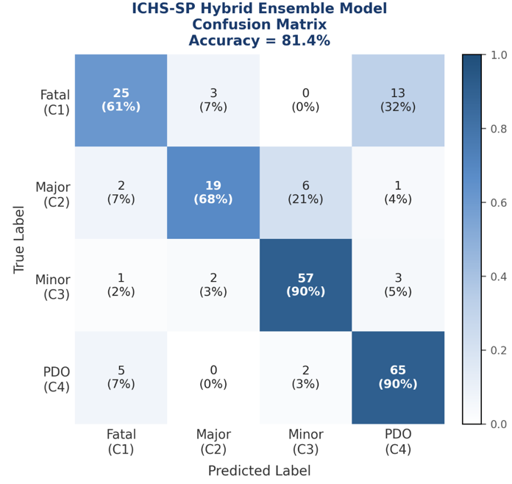
$Fig. 6$Confusion matrix of the hybrid ensemble model

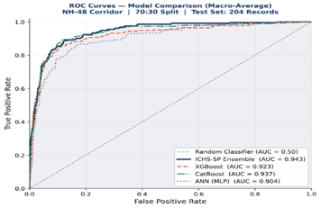
Fig 7. ROC Curves

Model Comparison
(Macro-Average), NH-48 Corridor, Test Set n = 204
Figure 6 displays the confusion matrix for the proposed hybrid ensemble model, ICHS-SP, over the 204-record test set. Here, the values along the diagonal represent the number of correct classifications (total = 166, or 81.4% accuracy), and the values along the off-diagonal represent the associated misclassification behaviors
Fig. 7. Macro-average ROC curves for the ICHS-SP ensemble method and three base models: XGBoost, CatBoost, ANN, on the NH-48 test data ($n = 204, 70:30$ split), using a one-vs-rest (OvR) approach across four severity levels: C1, C2, C3, and C4. The dashed line indicates a random classifier with AUC = 0.50. The ICHS-SP ensemble method has a uniform dominance over all base models across the entire false positive rate range with AUC = 0.943, w₁ = 0.35, w₂ = 0.35, w₃ = 0.30.

- CONCLUSION AND FUTURE SCOPE
The Study proposed the Integrated Chainage-based Hotspot Severity Prediction (ICHS-SP) framework for road accident risk assessment on the NH-48 highway corridor connecting Chitradurga and Davangere in the state of Karnataka, India. The ICHS-SP framework brings together the three components of multi-method spatial hotspot analysis, the Crash Severity Risk Index (CSRI), and the hybrid ensemble machine learning algorithm under a single umbrella, applicable to the geo-referenced set of 699 road accidents on the corridor stretch of 71 km (CH 189-260 km).
From a practical perspective, the CSRI-based risk ranking offers a directly implementable intervention priority schedule for the NH-48 Chitradurga-Davangere corridor. For instance, Zones 1 and 2, both Critical with CSRI > 2.70, demand immediate high severity interventions such as geometric realignment, sight distance correction, and speed enforcement. Zones 3 and 5, both High with CSRI ranging from 2.056 to 2.141, require high volume accident frequency reduction interventions such as junction improvement, pavement improvement, and graduated speed zone implementation. Zone 4, which is Moderate with CSRI = 1.247, suggests routine monitoring. The ensemble severity predictions may further be utilized in conjunction with the CSRI values to generate expected severity maps for individual segments of the road, which may dynamically update as new accident records are incorporated, thus offering an increasingly intelligent risk assessment tool for state highway authorities as well as the NHAI.
Future research should extend the current framework to incorporate more traffic, geometric, and environmental factors. It may be useful to investigate more sophisticated spatiotemporal and graphical approaches for finding complex spatiotechnical relationships along various corridors. The method could also be adapted for multi-corridor and network-level analyses and integrated into intelligent transportation systems.

References
1. Z. Xie and J. Yan, "Kernel density estimation of traffic accidents in a network space," Computers, Environment and Urban Systems, Vol. 32, No. 5, 2008, pp. 396–406.
2. J. Silva, A. Teixeira and J. F. Teixeira, "Spatial clustering of road accidents using GIS and machine learning," ISPRS International Journal of Geo-Information, Vol. 12, No. 6, 2023.
3. D. Endashaw, "GIS-based spatial analysis of road traffic accidents: a systematic review," Discover Cities, Springer, 2025.
4. P. Liu and J. Wang, "Linear referencing and spatial segmentation for highway safety analysis," Transportation Research Record, 2019.
5. Ș. Bilașco et al., "GIS-based spatial model for road accident risk assessment," Applied Sciences, Vol. 14, No. 6, 2024.
6. M. Ahmed et al., "Integrating GIS and statistical models for accident risk assessment," Civil Engineering Journal, 2023.
7. A. Kumar et al., "Accident severity prediction using machine learning models," IEEE Access, 2023.
8. H. Chen et al., "Application of XGBoost in traffic accident severity analysis," Transportation Research Procedia, 2019.
9. S. Sharma et al., "Deep learning approaches for road accident severity prediction," Frontiers in Built Environment, 2022.
10. A. Rahman et al., "Stacking ensemble models for traffic accident severity prediction," EAI Endorsed Transactions on Smart Cities, 2025.
11. M. Alhajri et al., "Hybrid machine learning models for traffic accident prediction," Periodica Polytechnica Transportation Engineering, 2024.
12. Y. Li et al., "Machine learning and spatial analysis for road accident prediction," Results in Engineering, 2024.
13. A. Mekonnen et al., "Predicting road accident severity using spatial machine learning models," Scientific Reports, 2025.
14. J. Levine, CrimeStat: A Spatial Statistics Program for the Analysis of Crime Incident Locations, Ned Levine & Associates, 2015.
15. A. Getis and J. K. Ord, "The analysis of spatial association by use of distance statistics," Geographical Analysis, Vol. 24, 1992, pp. 189–206.
16. L. Anselin, "Local indicators of spatial association — LISA," Geographical Analysis, Vol. 27, 1995, pp. 93–115.
17. M. Erdogan, "A comparison of kernel density estimation and Getis-Ord methods for hotspot analysis of traffic accidents," Journal of Transport Geography, Vol. 17, 2009, pp. 1–11.
18. V. Prasannakumar et al., "Spatial analysis of road accident hotspots using GIS," Accident Analysis & Prevention, Vol. 43, No. 1, 2011, pp. 317–325.
20. A. Okabe, K. Okunuki and S. Shiode, "SANET: a toolbox for spatial analysis on a network," Geographical Analysis, Vol. 38, No. 1, 2006, pp. 57–66.
19. M. Bíl, R. Andrášik and Z. Janoška, "Identification of hazardous road locations of traffic accidents by means of kernel density estimation and cluster significance evaluation," Accident Analysis & Prevention, Vol. 55, 2013, pp. 265–273
21. J. Xie, Z. Yan and M. Zhao, "Network kernel density estimation for traffic accidents," Journal of Transport Geography, Vol. 26, 2013, pp. 38–47.
22. D. Delen, R. Sharda and M. Bessonov, "Identifying significant predictors of injury severity in traffic accidents using a series of artificial neural networks," Accident Analysis & Prevention, Vol. 38, No. 3, 2006, pp. 434–444
23. C. Chang and C. Wang, "Analysis of traffic injury severity: a classification tree approach," Accident Analysis & Prevention, Vol. 38, No. 5, 2006, pp. 1019–1027.
24. A. Montella et al., "Data mining techniques for crash severity analysis," Accident Analysis & Prevention, Vol. 43, 2011, pp. 199–206
25. Y. Zou et al., "A deep learning approach for accident severity prediction," Accident Analysis & Prevention, Vol. 123, 2019, pp. 1–10.
26. S. M. Iranitalab and A. Khattak, "Comparison of machine learning methods for crash severity analysis," Transportation Research Record, 2017.
27. T. Chen and C. Guestrin, "XGBoost: a scalable tree boosting system," in Proceedings of the 22nd ACM SIGKDD International Conference on Knowledge Discovery and Data Mining, ACM, New York, 2016, pp. 785–794.
28. L. Prokhorenkova et al., "CatBoost: unbiased boosting with categorical features," in Proceedings of the 32nd Conference on Neural Information Processing Systems (NeurIPS), Curran Associates, Inc., Red Hook, NY, 2018, pp. 6638–6648.
29. Z.-H. Zhou, Ensemble Methods: Foundations and Algorithms, CRC Press, Boca Raton, FL, 2012.
30. T. G. Dietterich, "Ensemble methods in machine learning," in Proceedings of the 1st International Workshop on Multiple Classifier Systems, Springer, Berlin, 2000, pp. 1–15
31. M. A. Abdel-Aty and A. Pande, "Identifying crash propensity using GIS and data mining," Journal of Safety Research, Vol. 38, 2007, pp. 475–485.
32. M. Yuan et al., "Integrating GIS and machine learning for traffic accident analysis," IEEE Access, Vol. 8, 2020, pp. 208698–208708.
33. S. Wang et al., "Spatiotemporal analysis of traffic accidents using GIS and machine learning," ISPRS International Journal of Geo-Information, 2021.
34. N. Behboudi et al., "Recent advances in traffic accident analysis and prediction," arXiv:2406.13968, 2024.
35. M. Amiri et al., "Machine learning approaches to traffic accident severity prediction," Scientific Reports, 2025.
36. A. Shangguan et al., "Predicting road traffic accident severity using VAE and GCN," Scientific Reports, 2025.
37. J. Cunha et al., "Predicting traffic accident severity in Portugal using machine learning," Sustainability, 2025.
38. J. Tang et al., "Traffic accident severity prediction using machine learning," Sustainability, 2025.
39. O. Aboulola et al., "Improving traffic accident severity prediction using MobileNet and transfer learning," PLOS ONE, 2024.
40. A. Li et al., "Traffic accident risk prediction based on deep learning models," PLOS ONE, 2025.
41. P. R. Nobin and I. Rifat, "STARN-GAT: spatio-temporal graph attention network for accident severity prediction," arXiv:2507.20451, 2025.
42. A. N. Tripathi and B. Sharma, "A deep review: techniques, findings and limitations of traffic flow prediction using machine learning," in Proceedings of the 2nd International Conference on Advanced Machine Learning and Modern Technologies (AMMT), 2022, pp. 21–34, 2023.
43. Ministry of Road Transport and Highways, Road Accidents in India 2023, Transport Research Wing, Government of India, New Delhi, India, 2024.

